Contact: Aaron Mittel, MD, MSc; am4656@cumc.columbia.edu; cell 561-707-0392
List of Data Requested for QI Project, anti-Xa vs aPTT Discordance among Patients on ECMO in 2024
Notes:
- The primary focus of this project is to develop a clinical protocol to diagnose/treat discordance between aPTT and anti-Xa, which are blood-based markers of anticoagulation measured in the clinical laboratory. These lab values themselves are affected by other measures of coagulation (e.g. INR, international normalized ratio) as well as things which influence the lab machine itself (e.g. high bilirubin, which discolors blood and makes the anti-Xa color-based assay inaccurate). Thus, numerous labs are requested, as below.
- We would like time-stamped values based on the time the result occurred (NOT the time the lab data was ordered by a clinician)
- We are only interested in these values while the patient is on ECMO.
- Many of these labs are measured multiple times per day during the entire duration of a ECMO care (which may range from hours to months). Thus, the amount of data available for each patient might be large and will be different for each patient.

Medications:
- Heparin dose
If possible, we would like to know the PRECEDING/concurrent heparin infusion rate (units/kg/hour) at the time in which anti-Xa and aPTT result (based on PRECEDING heparin rate).
- E.g. if a patient is started or changed to 10 units/kg/hr heparin infusion at 6 a.m. and then increased to 12 units/kg/hr at 9:30 a.m., and the anti-Xa value is 0.15 IU/mL at 9 a.m., we would like to know the value of 10 units/kg/hr (as this likely requests the heparin infusion rate at the time the lab occurred, followed by a change in dose made in response to an anti-Xa that is below a clinical target.
- Nearest neighbor may not always be accurate, as the nearest heparin rate nearest may be AFTER the lab value was seen by clinical team.
Note: we do not care about subcutaneous intermittent injected heparin, which is typically ordered as 5000 units, subcutaneous, every 8 hours. This is different than continuous infusion heparin, which is administered as units/kg/hour.
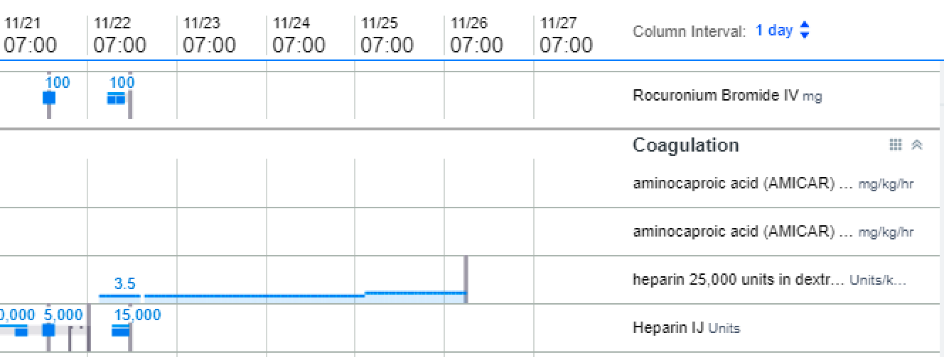
In this screenshot from “Med Dose Timeline”, we are interested in the heparin running at 3.5 units/kg/hour. We are not interested in the “heparin IJ” units.

Labs and screenshots of a patient (all from MRN 1401969069 unless otherwise specified):
- aPTT = “APTT”
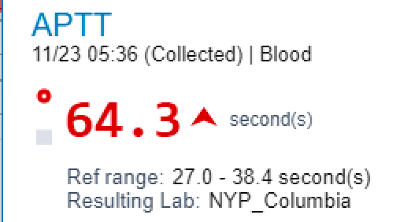
- Anti-Xa = “heparin, unfractioned/LMW, chromo”
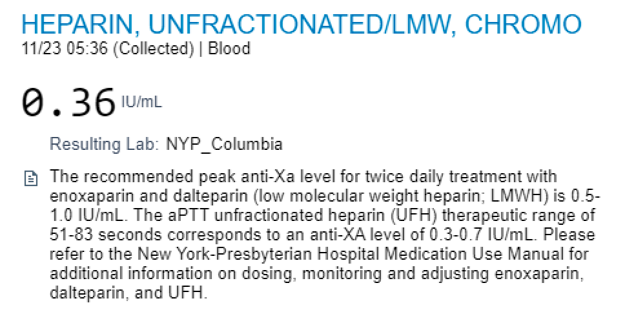
- Platelets = “Platelet count, auto”
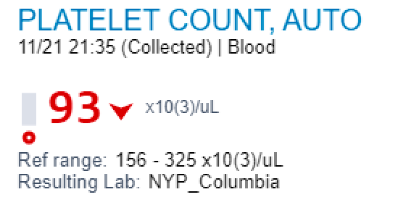
- INR
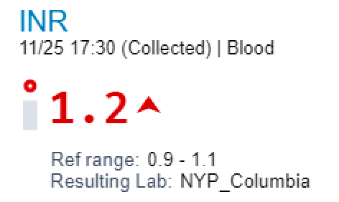
- Fibrinogen = “fibrinogen activity”
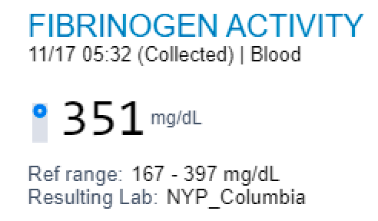
- bilirubin, total
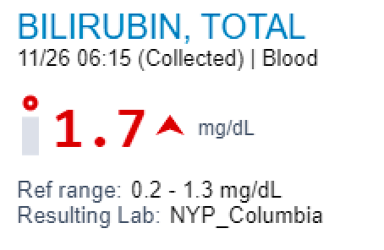
- Bilirubin, direct
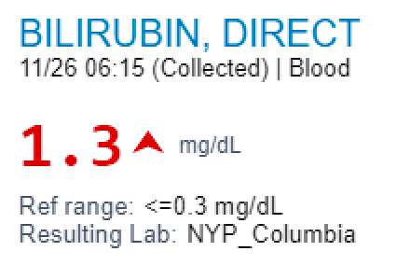
- Bilirubin, indirect
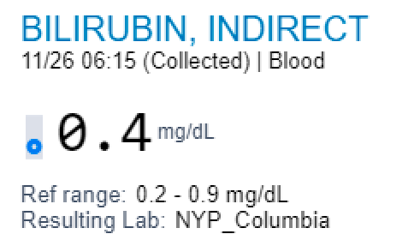
- Triglycerides (anticipate many missing values) = “triglycerides, serum”
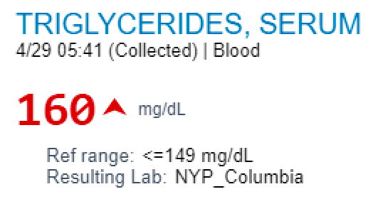
This is from MRN 1402126716

- Lactate dehydrogenase (anticipate many missing values) = “lactate dehydrogenase, reaction lactate to pyruvate”
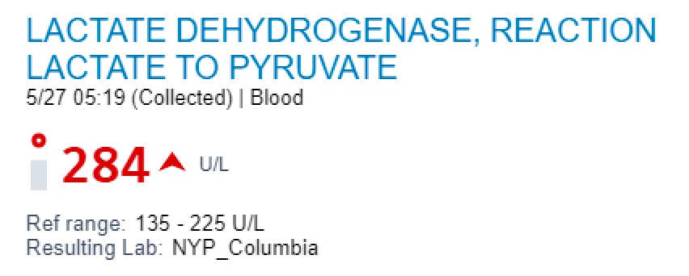
This is from MRN 1402126716

- Plasma free hemoglobin (anticipate many missing values) = “hemoglobin, plasm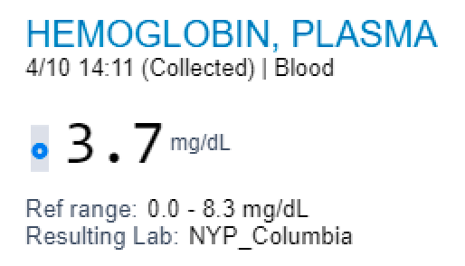
This is from MRN 1402126716

- Haptoglobin (anticipate many missing values)

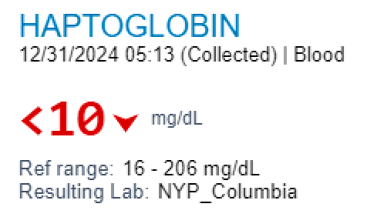
This is from MRN 1001799871

